11. ReactJS HandsOn

Create a React Application “eventexamplesapp” to handle various events of the form elements in HTML.

- Create “Increment” button to increase the value of the counter and “Decrement” button to decrease the value of the counter. The “Increase” button should invoke multiple methods.
  - To increment the value
  - Say Hello followed by a static message.

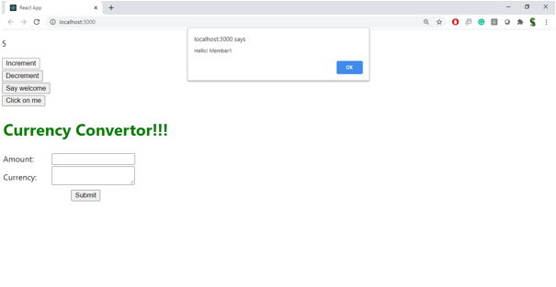

- Create a button “Say Welcome” which invokes the function which takes “welcome” as an argument.

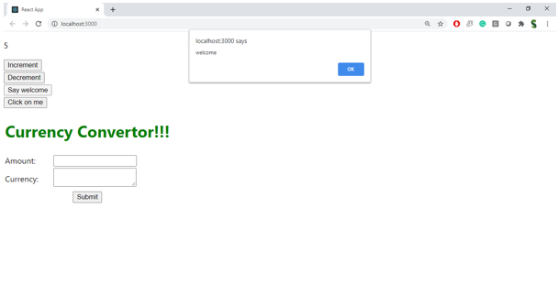

- Create a button which invokes synthetic event “OnPress” which display “I was clicked”

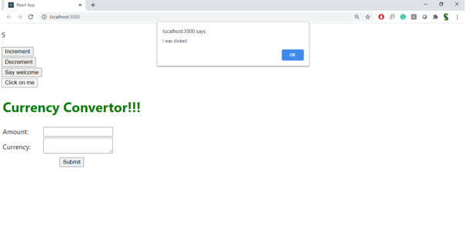

Create a “CurrencyConvertor” component which will convert the Indian Rupees to Euro when the Convert button is clicked.

Handle the Click event of the button to invoke the handleSubmit event and handle the conversion of the euro to rupees.

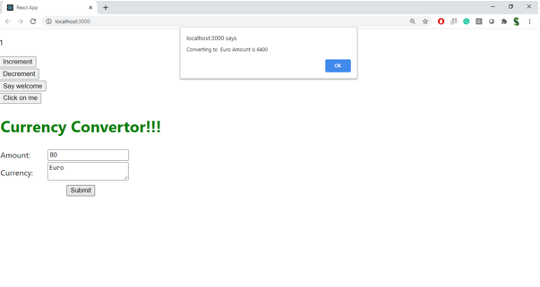

Project Structure:
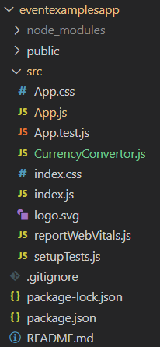

CurrencyConverter.js

import React, { useState } from "react";

const CurrencyConvertor = () => {
const [amount, setAmount] = useState("");
const [currency, setCurrency] = useState("");
const [converted, setConverted] = useState(null);

const handleSubmit = (e) => {
e.preventDefault();

// For simplicity, assume 1 Euro = 0.0100 INR
const conversionRate = 0.0100;
const result = parseFloat(amount) * conversionRate;

if (!isNaN(result)) {
setConverted(result.toFixed(2));
setCurrency("Euro");
alert(`Converted Amount: ${result.toFixed(2)} Euro`);
} else {
alert("Please enter a valid amount.");
}
};

return (
<div style={{ marginTop: '30px' }}>
<h2 style={{ color: 'green' }}>Currency Convertor!!!</h2>
<form onSubmit={handleSubmit}>
<label>Amount:</label>
<input
type="text"
value={amount}
onChange={(e) => setAmount(e.target.value)}
/><br /><br />
<label>Currency:</label>
<textarea
value={currency}
onChange={(e) => setCurrency(e.target.value)}
/><br /><br />
<button type="submit">Submit</button>
</form>
{converted && (
<p>
Converted Amount: <strong>{converted} {currency}</strong>
</p>
)}
</div>
);
};

export default CurrencyConvertor;

App.js

import React, { useState } from "react";
import CurrencyConvertor from "./CurrencyConvertor";

function App() {
const [count, setCount] = useState(0);

const increment = () => {
setCount(prev => prev + 1);
sayHello();
};

const decrement = () => {
setCount(prev => prev - 1);
};

const sayHello = () => {
alert("Hello! Member1");
};

const sayWelcome = (msg) => {
alert(msg);
};

const handleClick = (e) => {
alert("I was clicked");
};

return (
<div style={{ margin: '20px' }}>
<p>{count}</p>
<button onClick={increment}>Increment</button><br/>
<button onClick={decrement}>Decrement</button><br/>
<button onClick={() => sayWelcome("Welcome!")}>Say welcome</button><br/>
<button onClick={handleClick}>Click on me</button><br/>

<CurrencyConvertor />
</div>
);
}

export default App;

Outputs:

